# 

# 

# 

# 

**Walkaroo Manufacturing Company**

# 

### 

### Production Planning Process - Automation

### Project Documentation

Contents

1. Project Overview 3

2. Types of Orders 3

3. Manufacturing Process 3

4. Production Workflow 4

5. Planning Workflow 6

6. Planning Factors and Key Considerations 6

7. Production Planning Notes 7

8. Types of Molds 8

9. Planning Process Summary 8

10. Detailed Planning Process 9

11. Mould Plan & Order Creation Summary 15

12. Detailed Mould Plan & Order Creation Process 16

### Project Overview

This project aims to automate the production planning process at Walkaroo Manufacturing Company, which uses EVA compound and injection moulding to produce footwear. The primary goal of automation is to optimize machine utilization, reduce downtime, manage stock levels, and meet market demand efficiently.

**Company Background**

* **Product:** Footwear cases containing pairs.
* **Customers:** Primarily distributors (not retailers).
* **Production Overview:** Walkaroo produces footwear using EVA compounds and injection moulding machines. Production planning ensures that inventory levels are optimized, with minimal mould and colour changes to maximize machine uptime and reduce costs.

### Types of Orders

1. **Norm Orders**
   * Demand is forecasted based on the past year's data, generated through a software called Vector Flow.
   * Norms define stock levels, with Unit Decided Stock (UDS) maintained for each article. Inventory is categorized into A+, A, B, C, and D classes based on demand levels.
2. **Trade Show Orders**
   * New product samples shown to distributors without predefined Norms.
3. **MTO (Made To Order)**
   * Customized orders placed by distributors, separate from Norm requirements.
4. **NLMTO (New Launch Made To Order)**
   * Orders for newly launched articles.
5. **Export Orders**
   * Orders designated for export markets.
6. **Pull Back Orders**
   * Additional orders placed beyond the Norm requirement.

### Manufacturing Process

* **Raw Material:**
  + **Main Component:** EVA compound in two varieties:
    - **EVA 40** - Hard material.
    - **EVA 42.5** - Soft material.
  + **Vendors:** Blue Tyga (Taiwan) and Sandeep Industries.
  + **Other Materials:** PVC Resin, cartons, buckles, jibbits, velcro, etc.
  + Raw materials have different colours.
* **Equipment and Machinery:**
  + **Blenders:** 3 blenders to ensure uniform EVA compound consistency.
  + **Hoppers:** Two hoppers (left and right) feed EVA compound into injection molding machines.
  + **Injection Molding Machines:**
    - **Total:** 9 machines, 7 with 8 moulding stations and 2 with 6 moulding stations.
    - Each station holds 2 moulds.
    - Capacity of the plant is 48,000 pairs, whereas the current production is around 32-35,000 pairs.
  + **Rotary and Horizontal Machines:** Produce Finished Uppers (FIU) with 3 rotary and 2 horizontal machines.
  + **Pad Printing and Screen Printing Machines:** Used for brand logo and design application.
  + **Conveyor System:** Divided into left and right sections to streamline assembly and QC.

### Production Workflow

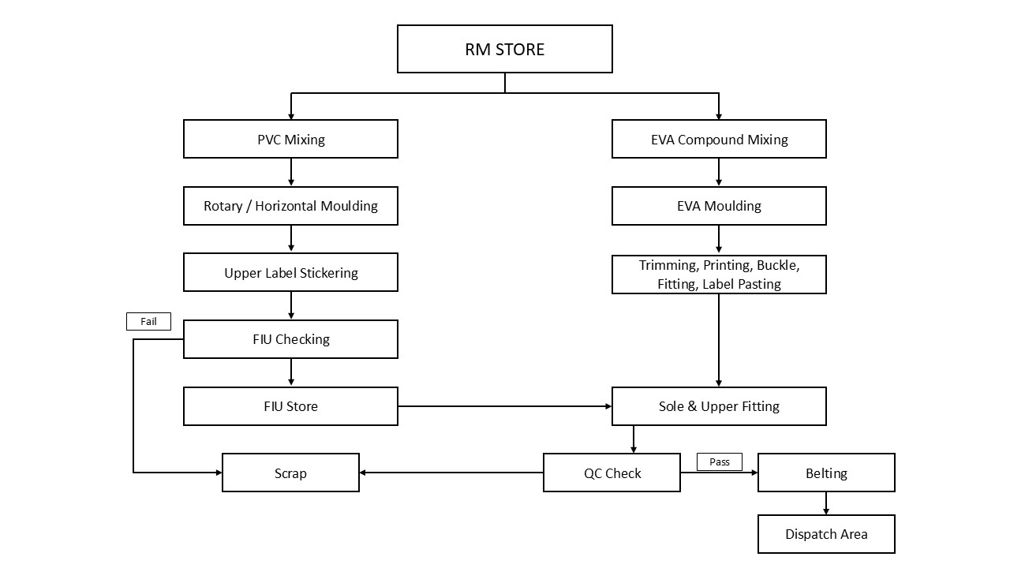

This workflow diagram represents the manufacturing process from the RM (Raw Material) Store to the final dispatch area. Here’s a breakdown of each stage:

**1. RM Store**

* The starting point for all raw materials required for PVC and EVA products.

**2. PVC Processing Path**

* **PVC Mixing:** Raw materials are blended to create the PVC compound.
* **Rotary / Horizontal Moulding:** The PVC compound is shaped using rotary or horizontal moulding machines.
* **Upper Label Stickering:** Labels are attached to the upper part of each product.
* **FIU Checking:** A quality control step where items are inspected. Products that fail are directed to Scrap, while approved items proceed.
* **FIU Store:** Temporarily stores approved items before moving to the next stage.

**3. EVA Processing Path**

* **EVA Compound Mixing:** Raw materials are mixed to produce the EVA compound.
* **EVA Moulding:** The EVA compound is moulded into shape.
* **Trimming, Printing, Buckle, Fitting, Label Pasting:** Post-moulding steps include trimming excess material, attaching labels, adding buckles, and completing any additional fittings.

**4. Combined Stage - Sole & Upper Fitting**

* Both PVC and EVA products move to this stage, where soles and uppers are assembled together.

**5. Quality Control (QC) - Multiple Checks**

* **Mold Damage Check:** Molds are inspected for damage near the moulding station before production begins.
* **Size Check:** Each piece undergoes a size check to ensure it meets specifications.
* **Final QC Check:** A final quality inspection is conducted after assembly. Products that pass proceed to Belting, while those that fail go to Scrap.

**6. Conveyor Feeder Machine - Supporting Multiple Processes**

* **Trimming:** Removes excess material (flash) from footwear.
* **Labelling and Tagging:** Applies labels and tags to each footwear item for identification.
* **Shiner:** Polishes the footwear to enhance appearance.
* **Packing:** Pairs are packed into small boxes, stickers with details are applied, and pairs are scanned for tracking.
* **Loading:** Packs are loaded into master cartons.

**7. Packing and Belting**

* **Pairs Boxing:** Individual pairs are boxed, labelled, and placed into master cases.
* **Belting Machine:** Seals master cases with belts and tape for secure packaging.
* **Random QC Check:** Open cases undergo a random quality inspection before final sealing.

**8. Pair Stock**

* Any excess stock that surpasses grid requirements is kept separately as Pair Stock.

**9. Dispatch Area**

* After the final QC and belting, cases are moved to the dispatch area, where they are prepared for shipping.

**Additional Notes:**

* **Scrap**: Any product that fails quality checks (at the FIU or QC stages) is sent to the scrap area for disposal or recycling.
* **Conveyor Feeder Machine** (not shown but implied): Likely helps transport products between different stages for efficiency.

### Planning Workflow

1. **Demand and Forecast Review:**

* The start point of the planning are the forecast based on monthly/weekly projections per SKU, considering colour and design demands. This is shared by corporate. The review of this is base on which the plan will be created.

1. **Machine Allocation:**

* The raw materials that go into the product of the defined products are distributed across 9 machines based on demand and machine efficiency goals.

1. **Production Scheduling:**

* The schedule of

1. what item,
2. of what colour,
3. in what volume

is batched and assigned for production to various machines on the factory floor. While scheduling to reduce mold and colour changes.

1. **Monitoring and Adjustments:**

* There is also a real-time tracking of production efficiency, machine performance, and stock levels done that allows for the adjusting of production as needed.

1. **Reporting:**

* Reports generated at the end of each production cycle on machine utilization, downtime, and output for continuous improvement.

### Planning Factors and Key Considerations

**Planner Considerations for EVA Molding**

For effective mold planning, the EVA planner considers:

1. **Demand**: The planner checks current demand for different articles.
2. **Current Stock**: Stocks of articles in demand are assessed to avoid overproduction.
3. **Raw Material Availability**: Raw material levels are verified to ensure continuity.
4. **Mold Availability**: Only available molds are used in planning.
5. **Existing Molds in Machines**: Articles that are already loaded in machines from previous plans are prioritized.
6. **Finished Upper Availability**: Availability of FIUs is checked.
7. **Mold Change Requirements**: Mold changes are planned based on demand and mold availability. To reduce changes, similar designs are produced back-to-back. Whenever a change is needed, it's scheduled during breaks to avoid disrupting production.

**Priority of Demands**

1. **MTO** - Made-to-Order
2. **NLMTO** – New Launch Made-to-Order:
   * **Export**
   * **Tradeshow**
   * **NL Article**
   * **First Come First Serve**
3. **Back Order**
4. **CBR** - Continuous Black Red (demand-based stock replenishment)
5. **Norm** - Standard stock maintenance

### 7. Production Planning Notes

#### Stock Levels Categorization (Based on UDS):

1. **Black**: Zero stock.
2. **Red**: 33% of UDS.
3. **Yellow**: 33% - 66% of UDS.
4. **Green**: 66% - 100% of UDS.
5. **White**: Above 100% of UDS.

#### Shift Planning and Mold Changes

1. **Planning Period**: Planning is conducted for a 1-day period, covering three shifts.
2. **Mold Change Time**:
   * Mold changes take approximately 45 minutes to 1 hour.
   * Mold replacement process itself takes 10-15 minutes, followed by heating to a specific temperature.
3. **Color Change Time**:
   * Color changes take approximately 10 minutes.
4. **Injection Cycles**:
   * Total injections per hour per machine is 56.
   * Each injection moulding machine completes 7 injection cycles per hour, per station. Machine having 8 stations will give us 56 injections.(7*8)

#### Material Code Format

Example Material Code: **W08913L-DPNK-05x09C**

* **W**: Company Code (Walkaroo)
* **08913**: Article ID
* **L**: Gender (L - Ladies, G - Gents, K - Kids, GG - Gents Giants)
* **DPNK**: Color Code
* **05x09**: Size Combination (sizes 5 to 9)
* **C**: Case Code (A = 12, B = 24, C = 30, H = 20, D = 30)

### Types of Molds

1. Shoe Mold
2. Sole Mold
3. Last Mold

### 9. Planning Process Summary

1. **Stock Sheet**  
    *Purpose:* Tracks finished goods inventory from SAP to assess current stock levels. Key parameters include plant, storage location, and unit of measure to filter the data accurately.  
    *Source and Output:* SAP (T Code: ZSD_FREESTOCK_03), outputs stock data for further planning.
2. **Buffer Penetration Report (BPR)**  
    *Purpose:* Identifies Customer Buffer Requirement (CBR) demands to guide production needs.  
    *Source and Output:* Vector Flow System, outputs SKU-specific demand data.
3. **Buyer Order Report (BOR)**  
    *Purpose:* Aggregates buyer order data to support demand planning and inventory checks.   
   *Source and Output:* Vector Flow, outputs order data, filtered and cross-checked with Summary.
4. **NLMTO**  
    *Purpose:* Compiles New Launch MTO data for EVA plant orders to inform stock planning.  
    *Source and Output:* Vector Flow, outputs filtered MTO data aligned with Summary sheet for planning.
5. **MTO**  
    *Purpose:* Captures all MTO data excluding EVA plant to provide comprehensive demand information.  
    *Source and Output:* Vector Flow, outputs material orders for consolidated planning.
6. **Work In Progress (WIP)**  
    *Purpose:* Tracks production orders for ongoing processes from SAP, focusing on technically completed and closed statuses, with completion and target values.  
    *Source and Output:* SAP (COOIS), outputs order data on ongoing and completed production.
7. **Summary Sheet**  
    *Purpose:* Consolidates data from Stock, BPR, BOR, NLMTO, MTO, and WIP sheets to provide a comprehensive view for production planning and inventory management.  
    *Source and Output:* Data is sourced from various sheets (Stock, BPR, BOR, NLMTO, MTO, WIP) using VLOOKUP and formulas. Outputs include calculated columns for STOCK, STOCK 2 (CBR color-coded values), BAL TO PLAN, and CBR to support decision-making.

### 10. Detailed Planning Process

#### 1. Stock Sheet

**Purpose:** Contains details about the finished goods stock status.

**Source System**: SAP

**T Code:** ZSD_FREESTOCK_03 – FG Free Stock Report

**Steps to Retrieve Data**:

1. Select the report ZSD_FREE_STOCK_03 in SAP.
2. In the popup window, set the following parameters:
   * **Plant**: 1031
   * **Storage Location**: 1000
   * **Base Unit of Measure**: CS
   * **Radio Button Selection**: Normal
3. Click "Execute" to fetch the data.
4. Export the data or copy it into the STOCK sheet.

**Expected Data Structure**:

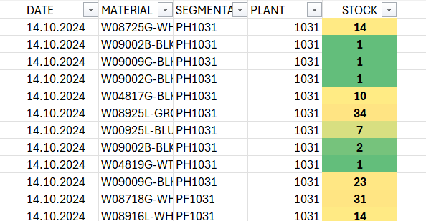

#### 2. Buffer Penetration Report (BPR)

**Purpose:** To find out CBR demand

**Source System**: Vector Flow

**Steps to Retrieve Data**:

1. Select Buffer Penetration Report from the Reports dropdown list.
2. In the popup window, select FG/FIU/RM as FG.
3. Export the data or paste it into the BPR sheet.

**Expected Data Structure**:

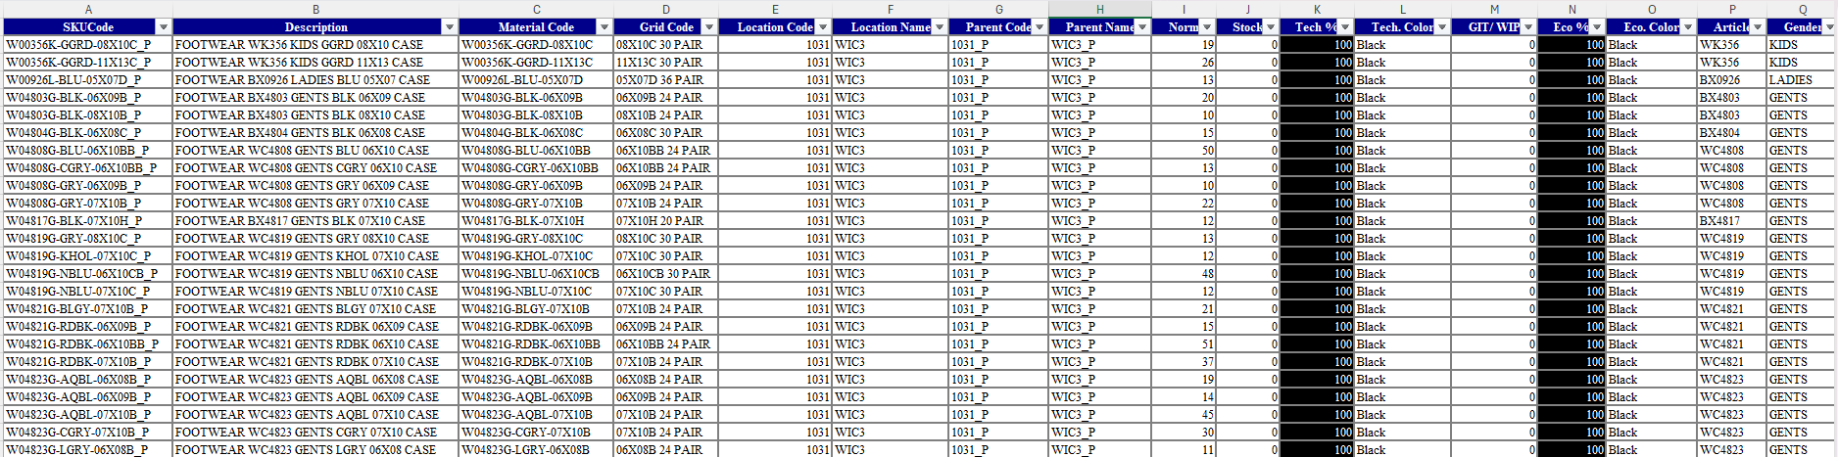

#### 3. Buyer Order Report (BOR)

**Purpose:** Details demand from buyer orders for material planning.

**Source System**: Vector Flow

**Steps to Retrieve Data**:

1. Select Buyer Order Report from the Reports dropdown list.
2. In the popup window, select the following fields:
   * **Plant**: 1031: WIC3
   * **All Suppliers**
   * **All SKUs**
3. Click "Show" to get the data.
4. Export the data or copy it into the BOR sheet.
5. Expected Data Structure

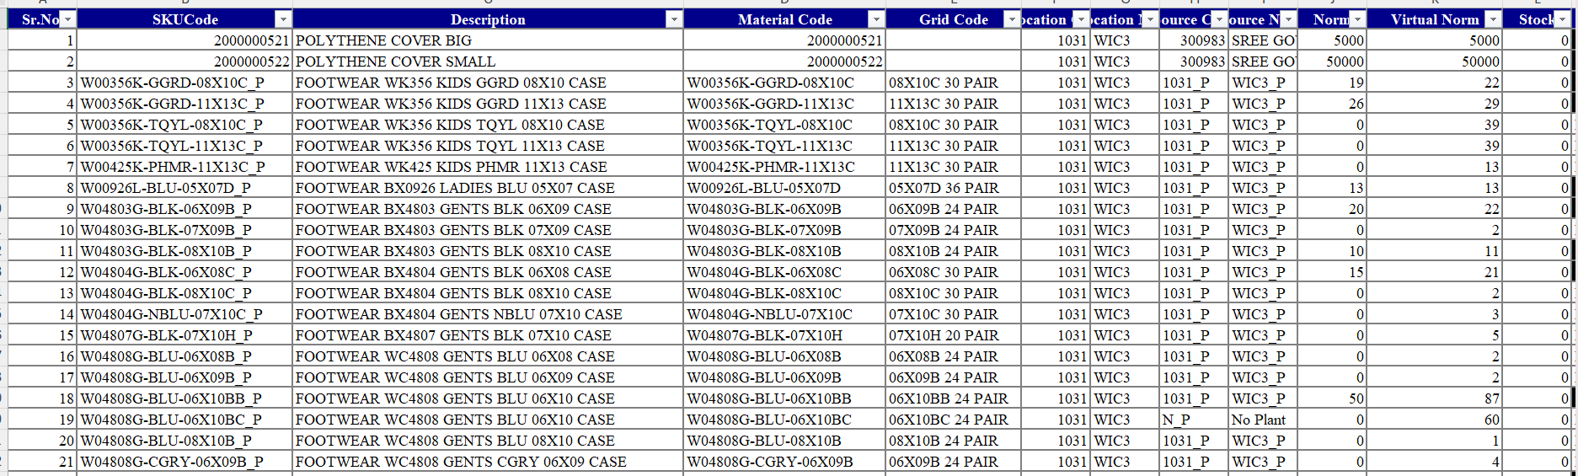

1. Add an additional column to check if the material already exists in the Summary sheet using a VLOOKUP formula.
2. Filter out NA values in the check column and filter FG in the FG/FIU column.
3. Copy the relevant material code line items into the Summary sheet. Remaining column values will be populated based on the VLOOKUP.

#### 4. NLMTO

**Purpose:** Captures New Launch MTO data.

**Source System**: Vector Flow

**Steps to Retrieve Data**:

1. Select Download Reports from the reports dropdown.
2. From the list of files, download the MTO Input Data ZIP file.
3. Open the ZMTO_NL_20241016 file within the ZIP folder.
4. Filter the Order Entry Location column for 1031 values (EVA plant code).
5. Copy the data into the NLMTO sheet.
6. Expected table structure

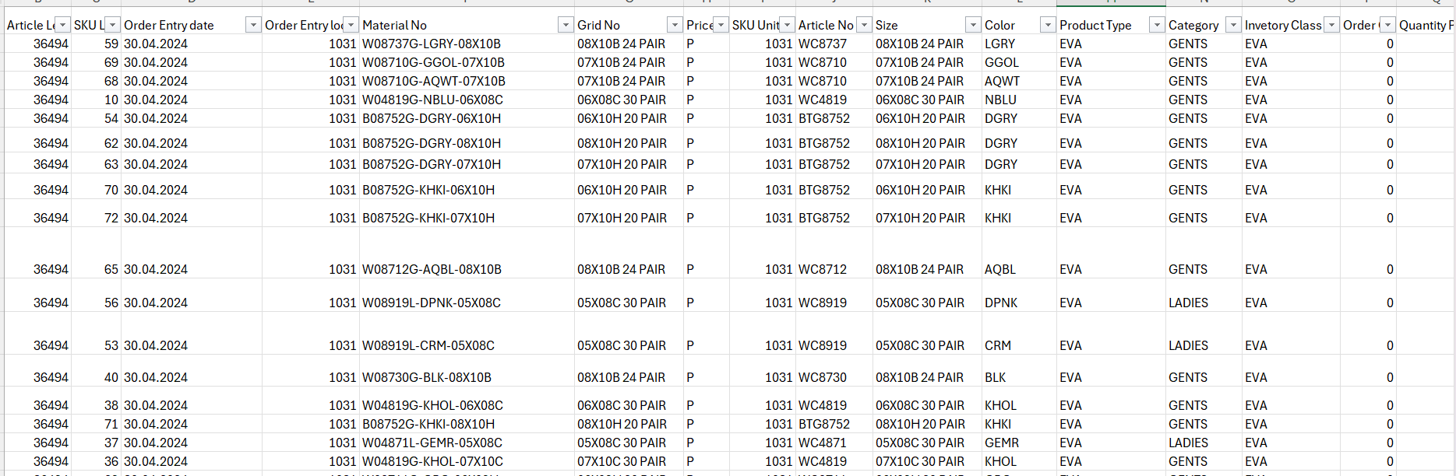

1. Add a VLOOKUP column to check if the material exists in the Summary sheet.
2. Filter out NA values from the check column.
3. Copy the relevant material code line items into the Summary sheet.

#### 5. MTO

**Purpose:** Provides MTO data for all locations except EVA plant.

**Source System**: Vector Flow

**Steps to Retrieve Data**:

1. Select Download Reports from the Reports dropdown.
2. Download the MTO Input Data ZIP file.
3. Open the ZMTO_NL_20241016 file from the ZIP folder.
4. Filter the Order Entry Location column for all values except 1031.
5. Filter the SKU Unit column for 1031 values.
6. Copy the data into the MTO sheet.
7. Expected table structure

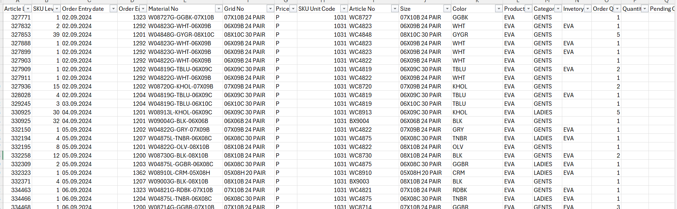

1. Add a VLOOKUP column to check if the material exists in the Summary sheet.
2. Filter out NA values in the check column.
3. Copy the relevant material code line items into the Summary sheet.

#### 6. Work In Progress (WIP)

**Purpose:** Tracks production status and order completion.

**Source System**: SAP

**Steps to Retrieve Data**:

1. Select COOIS – Production Order Information System.
2. Set the following filters:
   * **List:** Select **Order Headers** from the dropdown.
   * **Production Plant**: 1031
   * **Order Type**: ZP01 (Indicates Normal Production)
   * **System Status**: TECO (Technically Completed) and CLSD (Closed), both with the Excl checkbox enabled.
3. Set the date range:
   * **Basic Start Date**: 1.10.2024
   * **Basic Finish Date**: 23.10.2024
4. Click "Execute" to get the data.
5. Filter the Unit of Measure column for CS (Cases) values.
6. Copy the data into the WIP sheet.
7. Add a Target column with the formula Target – MAX(CNF, GR).
8. Use VLOOKUP to match data from the WIP sheet to the Summary sheet based on Material No.

**Expected Data Structure**:

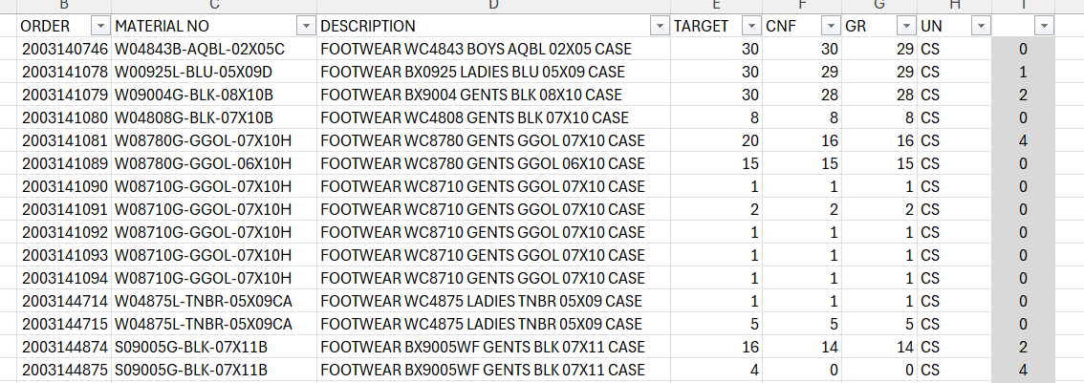

#### 7. Summary Sheet

**Steps to Retrieve Data**:

1. Once we get all the data into Stock, BPR, BOR, NLMTO, MTO and WIP Sheets.
2. Go to Summary Sheet and copy Material No, Cat, Mat Type, Sole Colour, Type, Article, Colour, Category and Size columns from BOR and NLMTO Sheets.
3. UDS column values directly from BPR Sheet using VLOOKUP formula.
4. Back Order and Order Qty Column values directly from BOR Sheet using VLOOKUP formula.
5. NLMTO column values directly from NLMTO sheet by using SUMIF formula.
6. MTO column values directly from MTO sheet by using SUMIF formula.
7. Create a new column as “STOCK”. get the values from stock sheet using Vlookup.
8. Add one more column as “STOCK CLR” to get the CBR colour values using If() formula. Colour values indicates the availability to produce quantity. CBR values will be follows below list:
   * Black: 0%
   * RED: 33%
   * YELLOW: 66%
   * GREEN: 99%
   * WHITE: >100%
9. WIP column values take directly from WIP sheet using SUMIF formula.
10. BAL TO PLAN column: to get the values using below formula
    * BAL TO PLAN = MTO + IF(ORDER >NLMTO, ORDER, NLMTO)
11. CBR column: these values are getting from BPR sheet.
12. Then remaining yellow columns indicates day wise planned case quantity based on tech colour.

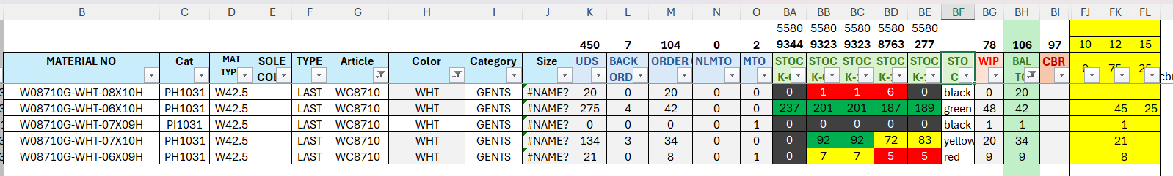

### 11. Mould Plan & Order Creation Summary

1. **Plan Summary Sheet**  
    *Purpose:* The production plan for various machines, detailing their daily capacities, planned output, and material specifics. It highlights each machine’s target production per cycle and day, along with associated materials and sole colors, indicating the utilization rate as a percentage of total capacity.
2. **Mould Plan Sheet**  
    *Purpose:* Details mould allocation and scheduling for different machines based on production needs.  
    *Source and Output:* Utilizes demand and material requirements to assign moulds, optimizing machine setup and changeovers.
3. **Rotary Plan Sheet**  
    *Purpose:* Outlines production scheduling for rotary machines to ensure continuous output.  
    *Source and Output:* Contains cycle plans and capacities for each rotary machine, aiming for efficient utilization.
4. **Machine Plan Sheet**  
    *Purpose:* Assigns production tasks to specific machines, balancing workload and capacity.  
    *Source and Output:* Uses capacity data to allocate production across machines, maximizing productivity.
5. **Order Creation Sheet**  
    *Purpose:* Facilitates the creation of production orders based on demand and material availability.  
    *Source and Output:* Generates new orders by consolidating stock, material, and demand data for seamless production planning.
6. **Pending Order Sheet**  
    *Purpose:* Tracks orders that are still in queue or awaiting completion to manage backlog.  
    *Source and Output:* Lists all pending orders by status, helping to prioritize and streamline production.
7. **Machine Order Sheet**  
    *Purpose:* Monitors orders assigned to specific machines, ensuring alignment with production capacity.  
    *Source and Output:* Lists machine-specific orders to track execution and progress for each production line.
8. **FIU-REQ Sheet**  
    *Purpose:* Records Finished Goods Inventory (FIU) requirements to meet demand forecasts.  
    *Source and Output:* Provides demand estimates to guide raw material and production planning.
9. **PVC MIX Sheet**  
    *Purpose:* Details the mix ratios and quantities for PVC material preparation in production.  
    *Source and Output:* Specifies PVC mix formulations required for various products, ensuring consistency and quality.
10. **Raw Material Sheet**  
     *Purpose:* Tracks raw material availability and requirements for ongoing production.  
     *Source and Output:* Consolidates material stock data to support procurement and inventory management.

### 12. Detailed Mould Plan & Order Creation Process

#### 1. Plan Summary Sheet

Plan Summary Sheet looks like this below image:

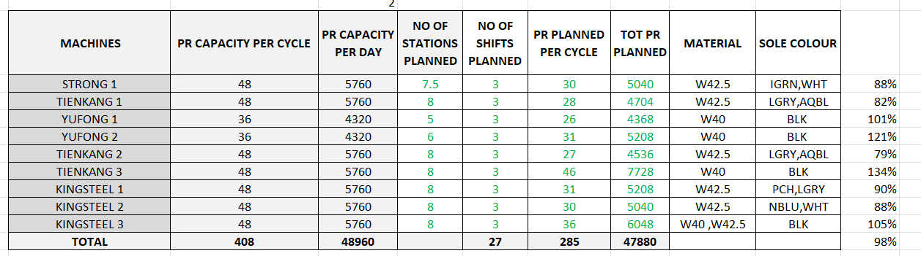

This table appears to represent a production plan for various machines, summarizing their daily capacity, planned production, and material details. Here’s a breakdown of each column:

1. **MACHINES**: Lists the names of each machine (e.g., STRONG 1, TIENKANG 1, etc.) used in the production process.
2. **PR CAPACITY PER CYCLE**: Indicates the production capacity (in units) for each machine per cycle. Most machines here have a capacity of 48 units per cycle, except for YUFONG 1 and YUFONG 2, which have 36 units.
3. **PR CAPACITY PER DAY**: The total production capacity per day for each machine, calculated by multiplying the per-cycle capacity by the number of cycles per day. For example, 48 units per cycle multiplied by the number of cycles gives 5760 units for most machines.
4. **NO OF STATIONS PLANNED**: Shows the number of stations assigned to each machine, influencing the overall output. This varies slightly across machines.
5. **NO OF SHIFTS PLANNED**: The number of shifts planned per day for each machine, set at 3 shifts across all machines.
6. **PR PLANNED PER CYCLE**: The planned production (units) per cycle for each machine. This is slightly lower than the maximum capacity per cycle, indicating planned production targets rather than maximum output.
7. **TOT PR PLANNED**: The total planned production for each machine, likely calculated by multiplying PR Planned per Cycle by the number of cycles per day or by factoring in shifts and stations.
8. **MATERIAL**: Lists the material codes (e.g., W42.5, W40) that each machine will produce.
9. **SOLE COLOUR**: The color(s) of the sole associated with each production line for different materials, given as color codes (e.g., IGRN, WHT for green and white).
10. **PERCENTAGE** (Final Column): Indicates the percentage of planned production compared to total production capacity. This suggests whether each machine is producing at, below, or above its full capacity. Values over 100% imply production above nominal capacity, while values below 100% indicate a plan below capacity.

#### 2. Mould Planning Sheet

1. **Demand and Capacity Check**
   * Evaluate demand, mould capacity, injection capacity, material stock (stored in 4000), and mould availability.

|  |  |  |  |  |  |  |
| --- | --- | --- | --- | --- | --- | --- |
| **Article** | **Gender** | **No of pair in a case** | **No of SET** | **No of pair in all size** | **Capacity with 1 pair** | **Total capacity per day** |
| BTG8752 | GENTS | 20 | 1 | 1 | 45 | 45 |
| WK356 | KIDS | 30 | 1 | 1 | 18 | 18 |
| WC4819 | GENTS | 30 | 2 | 3 | 30 | 90 |

* + Confirm mould capacity against the capacity master list for each article:
    - **Example Structure**:
      * **Article**: WC4819 (GENTS)
      * **Capacity with 1 pair**: 30
      * **Total Capacity per day**: 90

|  |  |
| --- | --- |
| **SIZE** | **PAIR** |
| 6*7*8 | **1** |
| 8*9*10 | 1 |
| 6AB | **2** |
| 7AB | 2 |
| 8AB | 2 |
| 9AB | 2 |
| 10AB | 2 |
| 1*2*3 | 1 |
| 3*4*5 | 1 |

1. **Mould Size Configurations**
   * Articles like WC4819 have specific size and mould configurations.
   * **Size Pairings**:
     + Sizes are assigned pairs, e.g., 6*7*8 (1 pair) or 6AB (2 pairs).
   * Adjust production based on the article's mould and size requirements.
2. **Injection Capacity**
   * Calculate total injections per station (7 per hour × 24 hours = 165 injections).
   * Example for mould 4819:
     + **Total Injection**: 165
     + **Packing Combination**: 6 pairs → 28 cases

|  |  |  |  |  |  |
| --- | --- | --- | --- | --- | --- |
| **4819 Mould** | **Tot Injection** | **Pair of mould** | **Tot Pair** | **Packing Combination** | **Total Case** |
| 6 | 165 | 1 | 165 | 6 | 28 |
| 7 | 165 | 1 | 165 | 6 | 28 |
| 8 | 165 | 1 | 165 | 6 | 28 |
| 9 | 165 | 1 | 165 | 6 | 28 |
| 10 | 165 | 1 | 165 | 6 | 28 |
| **Total** |  |  |  | **30 – 1 Case** | **168** |

1. **Stock Check in SAP (MB52)**
   * Use MB52 in SAP to view material stock for EVA compounds and other relevant materials.
   * **Steps**:
     + Plant: 1031
     + Storage location: 4000
     + Material Group: EVA
     + Click on the Execute Button to get the results.

|  |  |  |  |  |  |  |  |  |
| --- | --- | --- | --- | --- | --- | --- | --- | --- |
| **Material** | **Material Desc** | **Stock Seg** | **Unrestricted** | **Base Unit of Measure** | **Plant** | **Storage Location** | **Batch** | **Value Unrestricted** |
| Summer Green |  | 63 | 6360 | KG | 1031 | 4000 |  | 1273816.46 |
|  |  |  |  |  |  |  |  |  |

* + - Copy data, and paste into the material sheet. Material sheet looks like below table.

|  |  |  |
| --- | --- | --- |
| **EVA Compound** | **QTY** | **Case** |
| Summer Green | 6360 | 978 |
|  |  |  |

* The planner will review the articles currently running in the planning sheet and check the pending article file for any new articles or issues with existing articles. Then check the article list and update the sheet.

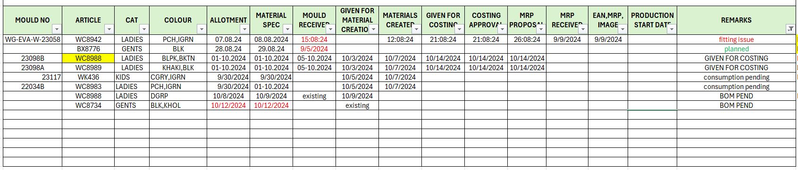

1. **Pair Stock Analysis**
   * Check stock for specific pairs in MB52 for storage location 1000.
   * **Steps**:
     + Plant: 1031
     + Storage location: 1000
   * Click on the Execute Button to get the results. Then filter the PR values in “Base Unit of Measure” column.

|  |  |  |  |  |  |  |  |  |
| --- | --- | --- | --- | --- | --- | --- | --- | --- |
| **Material** | **Mat Desc** | **Stk Seg** | **Unrestricted** | **Base Unit of Measure** | **Plant** | **Storage Location** | **Batch** | **Value Unrestricted** |
| W08710G-DGRY006 |  | E11031 | 17000 | PR | 1031 | 1000 | 06E11031 | 1533.57 |
|  |  |  |  |  |  |  |  |  |

* + For example, if you are checking article 8710 in the above table and data is present, it indicates there is pair stock available. If the demand is 200 but the production capacity is only 165 cases per day, pair stock can be utilized. If the mould type is AB, replace it with another mould that meets the same colour demand. If the mould is a combination mould (e.g., 6*7*8), block the specified size in this mould.
  + If you find any pair stock, convert it into pairs and update the summary sheet based on the category column and stock segment from the MB52 table.

1. The Final Mould Plan table looks like below table:

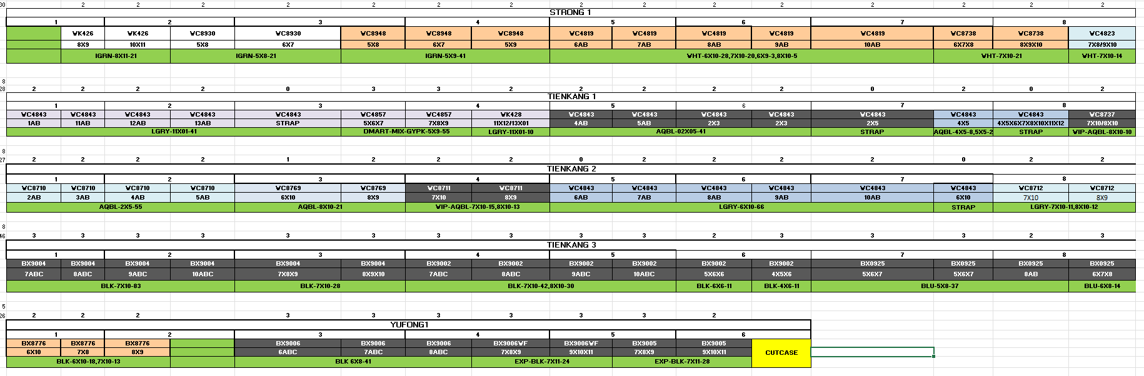

#### 3. Rotary Planning

**Stock Check for Rotary Machines**

1. Use MB52 in SAP for Finished Upper (FU EV and FU PV).
2. **Steps**:
   * Plant: 1031
   * Storage location: 2000
   * Material Group: FU EV and FU PV

* Click on Execute button to get the data.

|  |  |  |  |  |  |  |  |  |
| --- | --- | --- | --- | --- | --- | --- | --- | --- |
| **Material** | **Material Desc** | **Stk Seg** | **Unrestricted** | **Base Unit of Measure** | **Plant** | **Storage Location** | **Batch** | **Value Unrestricted** |
|  |  | 6 | 2975 | PC | 1031 | 2000 |  | 73816.46 |
|  |  | 7 | 675 | PC |  |  |  |  |

1. Then export this data in excel format.
2. Rotary plan will happen based on FIU store. No need to concentrate on mould change.
3. Only the sizes that are not listed in the stock should proceed to production.
4. **Example**: if the current mould is 4819 and stock only has sizes 6 and 7, check the summary sheet for article 4819 with black colour. If there is demand for sizes 7, 8, and 9, only sizes 8 and 9 will go to production.

|  |  |
| --- | --- |
| **Size** | **Total Cases** |
| 7*8 | 10 |
| 8*9 | 10 |
| 9*10 | 13 |

1. The final Rotary plan sheet looks like below image:

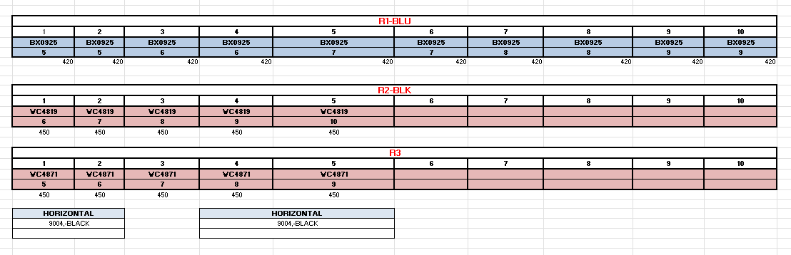

#### 4. Machine Plan Sheet

* Once all machines are planned, check the summary sheet for all orders with no blank values for the current date.
* Go to the “Machine Plan Sheet” and copy all material numbers into right side column (column V) of the machine plan sheet. Then, copy the Article, Colour, Category, Size, and planned quantity from the "Summary Sheet," specifically the FS (Planned Qty for current date) column.

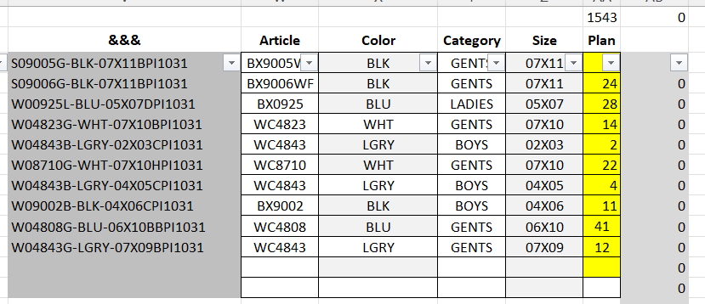

* Then compare left and right-side column and eliminate the extra rows.
* Perform auto-lookup to verify materials match the Summary Sheet, making necessary replacements (e.g., PH to PI, E1 to PI).
* This will ensure that articles and total cases match.
* Enter values manually in the tech colour column.
* Filter CS Plan Column with 0. Then divide this values by 3 and plan for 3 shifts. The final table looks like below table.

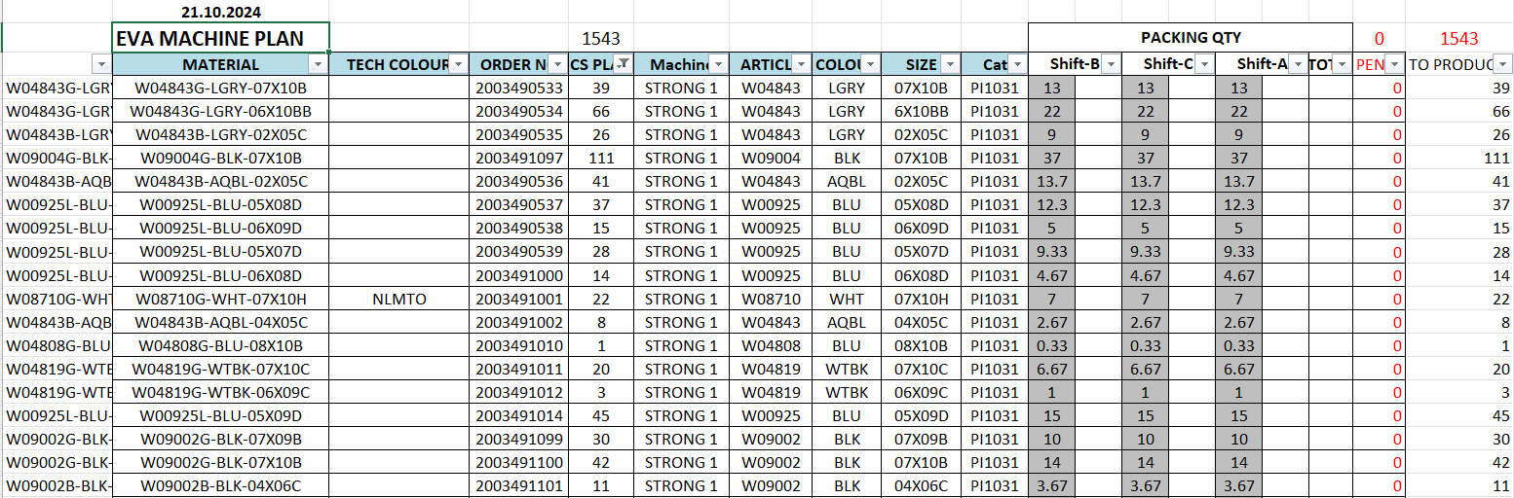

#### 5. Order Creation

1. Create a new excel file and name it as PR_Order File (0752_pr_order_20231103_26803NN).
2. Populate "Order Creation" columns based on predefined criteria:
   * **SKU** : Copy all material values from the Material column in the **Machine Plan Sheet**
   * **AWS_STOCK:** Copy Cat column values.
   * **Plant**: 1032 for all line items
   * **Order Type**: ZP01 (indicating Case or Pair Order)
   * **Quantity**: From CS Plan in the **Machine Plan Sheet**
   * **Priority**: Based on tech colour code entered manually (Red = R, Yellow = Y, White = W, Black = B).
   * The data is organized as follows:

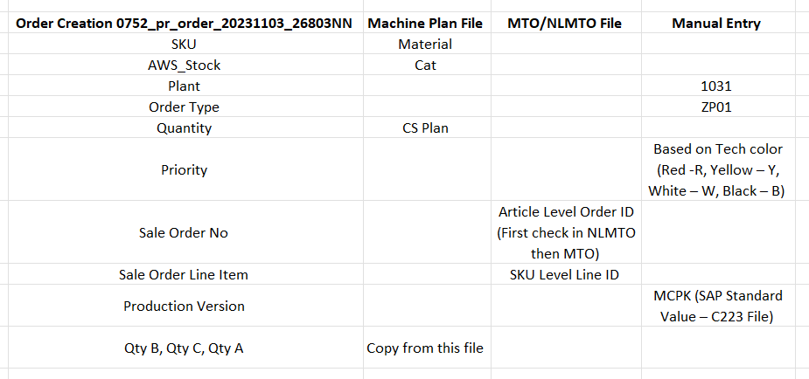

1. After completing all entries, the final table should look like this:

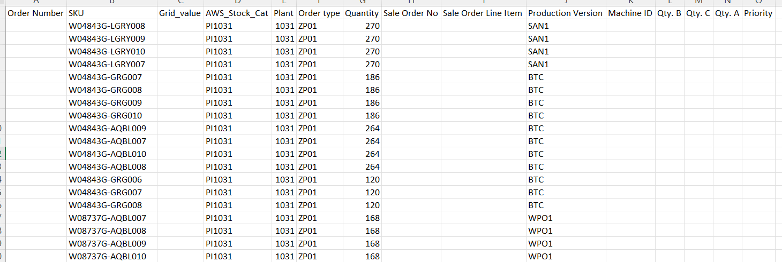

1. Once the final table is ready, Create an orders by upload it into SAP using the following steps:
   * Click on “ZPP – Create Production Order from FIle” file in SAP file list.
   * Select File in Radio button selection and click on Execute button.
   * Copy all newly created order numbers into the **Order No** column in the Machine Plan sheet.
2. Now Go to **COOIS – Production Order Information System** file from file list.
3. Set the following filters:
   * Select **Components** from the List dropdown.
   * Plant: 1031
   * Enter each **Production Order** one by one to create a pair order (e.g., enter Order No. 2003556430).
   * Click the **Execute** button.
   * A table will open with columns similar to this:

|  |  |  |  |  |  |  |  |  |  |
| --- | --- | --- | --- | --- | --- | --- | --- | --- | --- |
| **Order** | **Material** | **Material Description** | **Reqmt Qty** | **Entry Unit** | **Stk. Seg** | **Mat Group** | **Qty wthdrn** | **Plant** | **Location** |
|  |  |  |  |  |  |  |  |  |  |
|  |  |  |  |  |  |  |  |  |  |

1. Copy only pair values from this table into the **Pair Order Creation file** (0752_pr_order_20231103_26803NN).
   * Ensure that the Quantity column is in pairs.
2. Copy all order numbers into **Order No** column in the Machine Plan sheet

#### 6. Pending Order Sheet

**After Completing Order Creation File:**

1. Go to **COOIS file**, set the following filters:
   * Select **Order Headers** from the List dropdown.
   * Copy and paste all case order numbers into the Production Order section by clicking the last icon button.
   * A list of orders will display.
   * Filter for **CS** values in the **Unit** column, then copy all line items to the **PEND Order** sheet file.

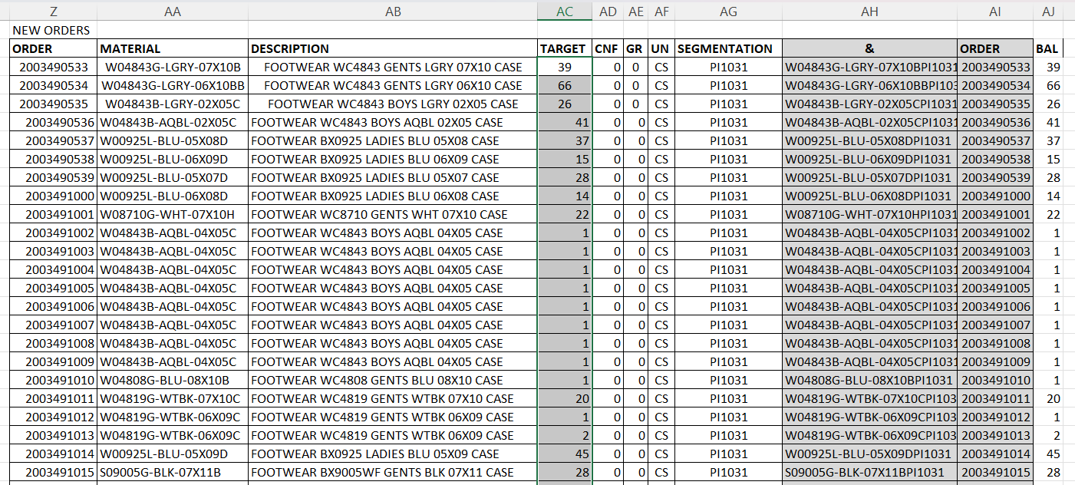

#### 7. Machine Order Sheet

**Creating the Machine Order Sheet:**

1. In the **COOIS file**, set the following filters:
   * Select **Items** from the List dropdown.
   * Copy and paste all pair and case orders into the Production Order section by clicking the last icon button.
   * A list of orders will display.
   * Filter for **CS** values in the **Order Type** column and copy all line items to the **Machine Order** sheet file.
   * Follow the same steps for pair orders by filtering for **PR** values in the **Order Type** column, then copy all line items into the **Machine Order** sheet file.

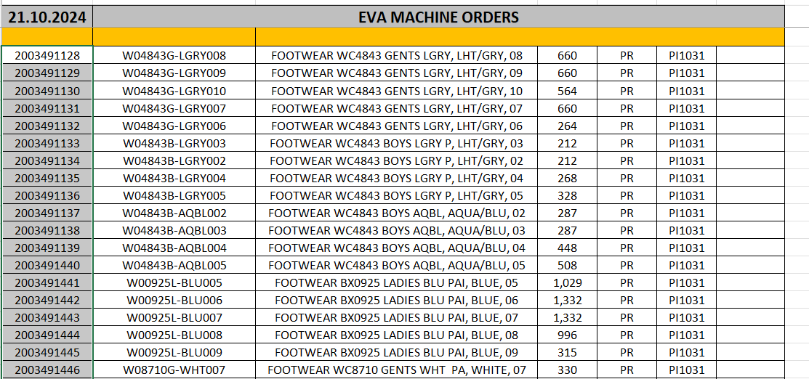

#### 8. FIU REQ – Finished Upper Requirement Sheet

1. Open the **COOIS** file and follow these steps:
   * Select **Components** from the List dropdown.
   * In the **Layout** section, choose **/FIU-1024**.
   * Copy and paste all the case orders into the Production Order section by clicking the last icon button.
   * A list of orders will display.
   * Copy all the order line items up to the **Unit** column and paste them into the **FIU REQ** sheet.
2. After finalizing the list, the planner will send this sheet to the **RM Store**.

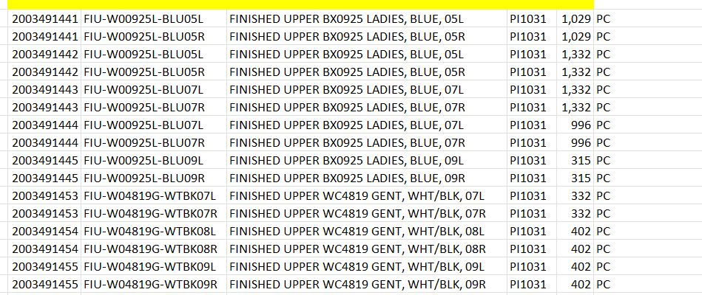

#### 9. PVC MIX Sheet

1. Open the **ZPP_SFG_PROD_03_Mass Order Creation File** to view the list of all Rotary machines.
   * Delete all existing data in the **ZPP_SFG_PROD_03** file.
2. The planner checks the **Mould Plan** sheet for Rotary machines and adds material numbers to the **ZPP_SFG_PROD_03** file.
   * Material numbers can be obtained from the **BOM** or **COOIS** files.
3. Enter **Category**, **Plant**, **Order Type**, and remaining columns manually.
4. The final **ZPP_SFG_PROD_03** file should look like the following:

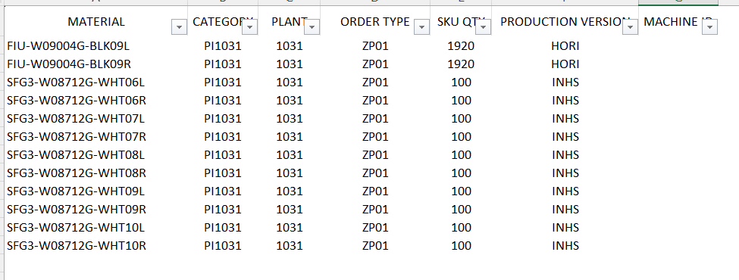

1. For example, if one rotary produces 20 injections per hour at one station, for one shift (8 hours), it will produce 160 injections (20 * 1 * 8). In 3 shifts (24 hours), it will produce 480 injections.
2. After completing the data entry, upload this file to SAP by following these steps:
   * Go to **ZPP_SFG_PROD_03_Production Order Create File** in SAP List.
   * Upload the **ZPP_SFG_PROD_03** Excel file to create orders, then copy all the order numbers into the **ORDERS** sheet.
   * Open the **COOIS** file in SAP, select **Components** from the List dropdown, paste the order list, and click **Execute** to display the raw material table.
   * Copy the **Material**, **Material Description**, **Reqmt Qty**, and **Entry Unit** column values into the **PVC MIX** Excel sheet.
   * Remove duplicate values, sum the quantities, and convert only PVC mix quantities into KGs.

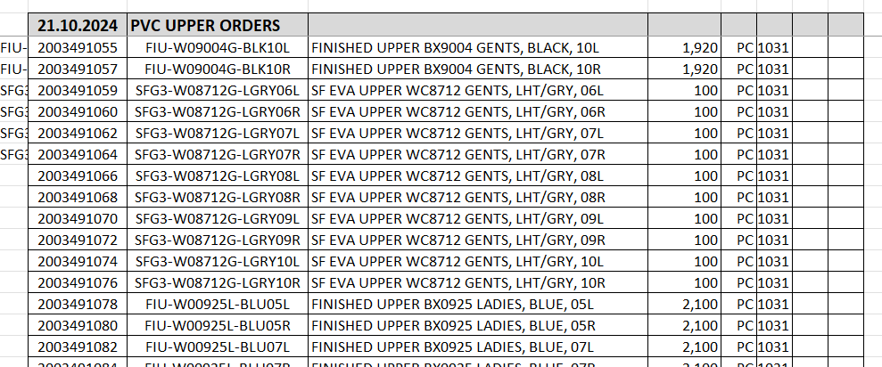

1. Open SAP **CO01** and enter the following:
   * **Material**: Copy each material number from the **PVC MIX** sheet, one at a time.
   * **Plant**: 1031
   * **Order Type**: ZP01
   * Click on **Execute** and enter the **Total Qty** for each related material as per the **PVC MIX** sheet.

#### 10. Raw Material Creation

1. Copy all **Case Order**, **Pair Order**, **FIU Order**, and **PVC MIX Order** IDs.
2. In SAP, open the **COOIS** file and follow these steps:
   * Select **Components** from the List dropdown.
   * Paste all IDs into the Production Order list by clicking the last icon button.
   * Click **Execute** to display all raw material details.
3. Copy these details into the **Rq RAW mtrl** sheet.
4. The planner will send this file to the Raw Material Store.

